Group No: A7 | | Week No: 4 | | Date: 20/07/2026

CAD Model Design by SolidWorks

Chassis Part and Dustbin Bucket
These two parts were modeled in SolidWorks. The chassis is the base plate that everything else mounts onto, and the dustbin bucket is the container piece that sits on top of it.
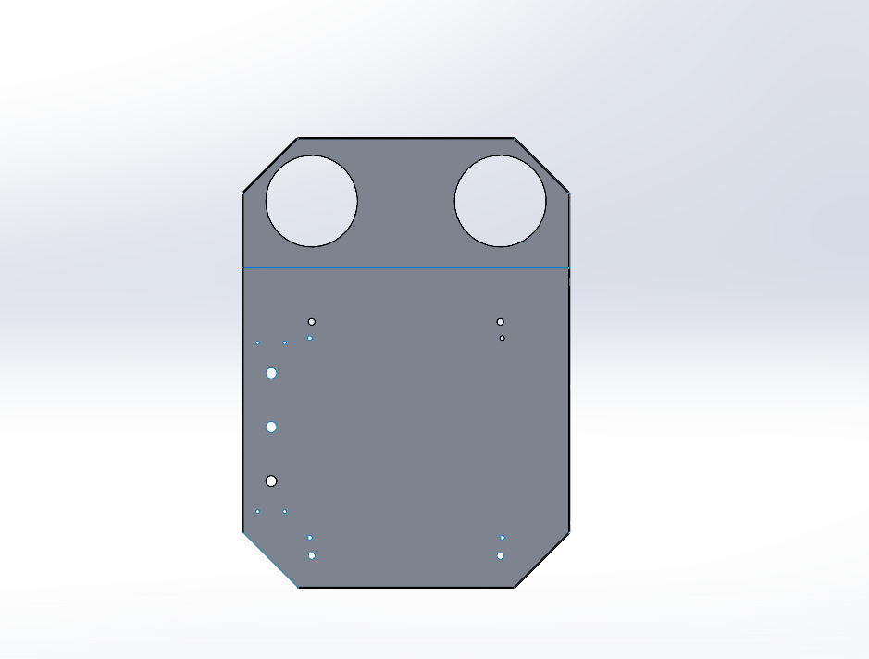
Figure 1: Chassis Part
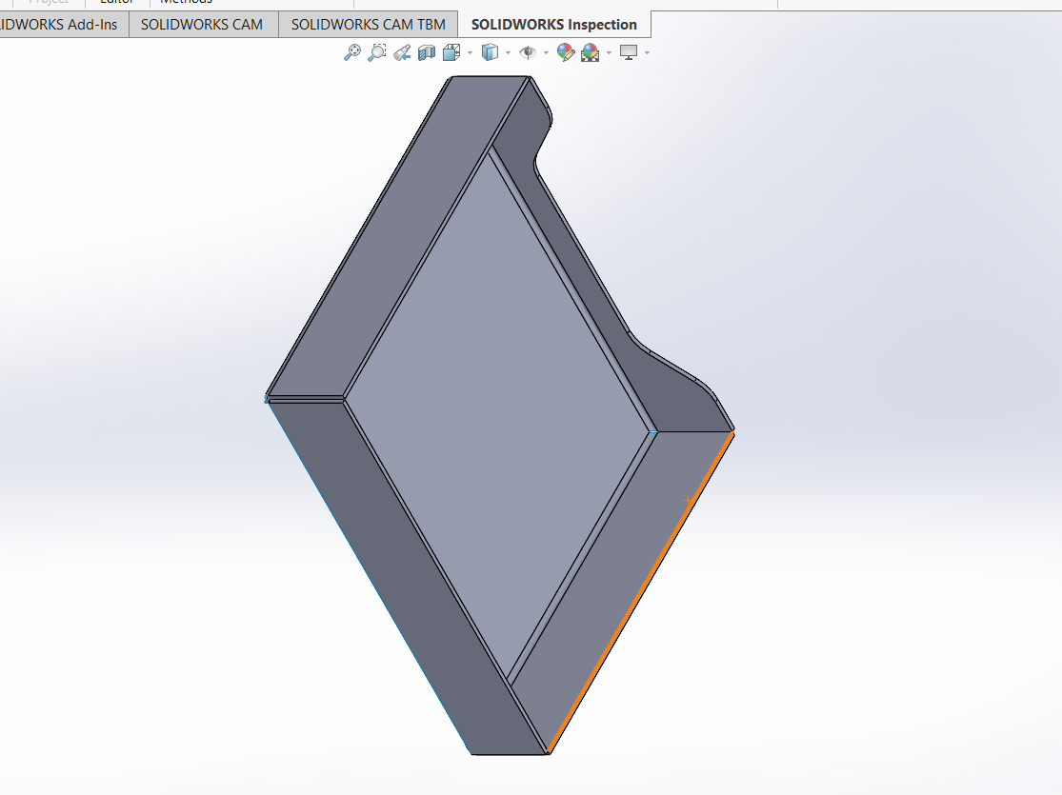
Figure 2: Dustbin Bucket

Raspberry Pi Holder
This part holds the Raspberry Pi board in place and keeps it protected. A few different views are shown below so the mounting holes and cutouts are easier to see.
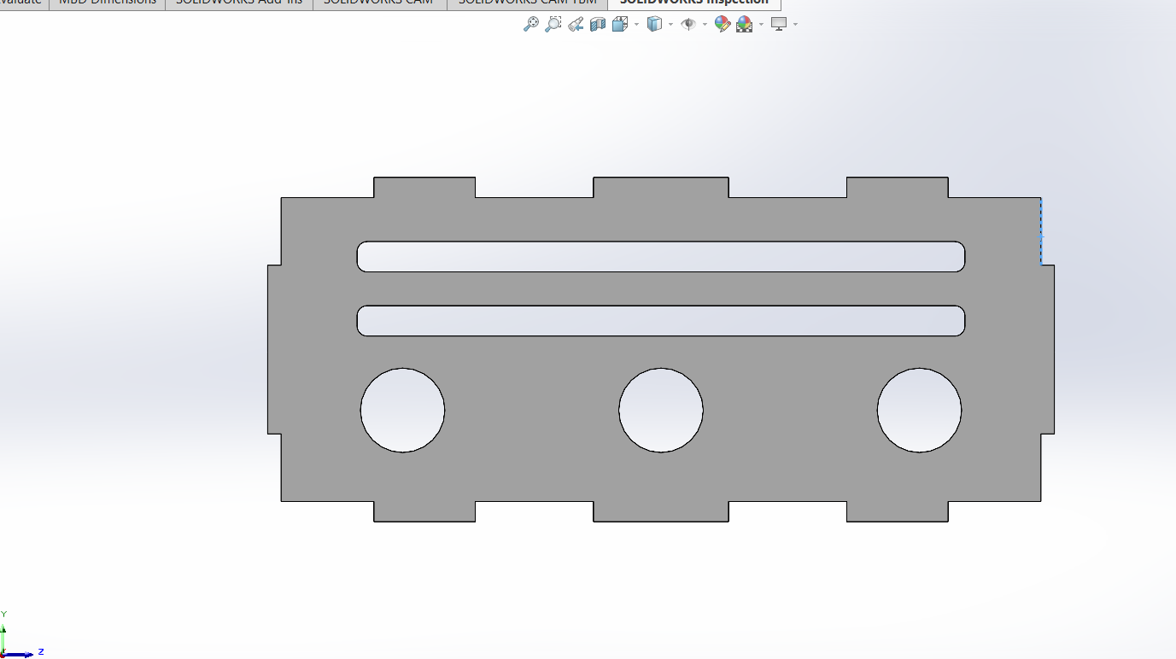
Figure 3: Top view
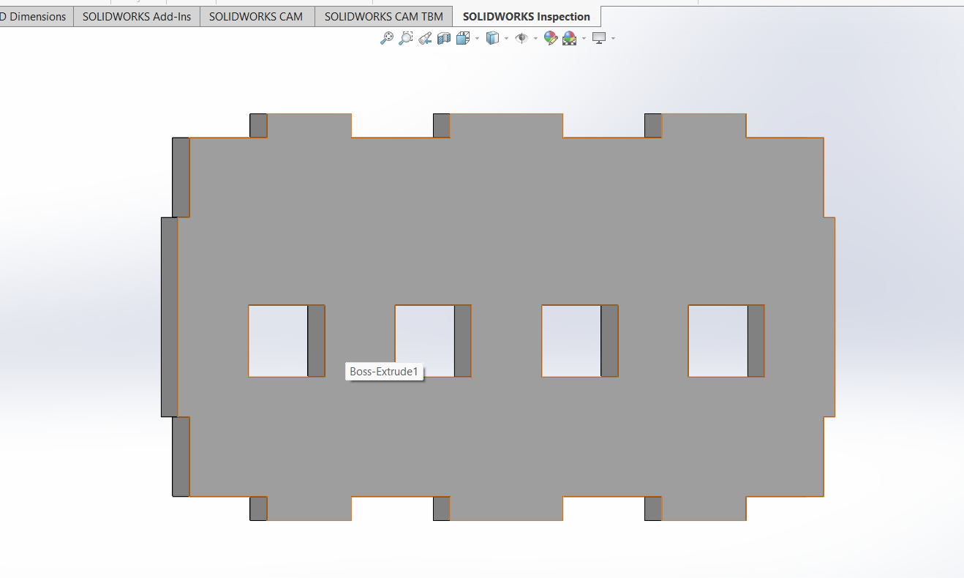
Figure 4: Alternate view
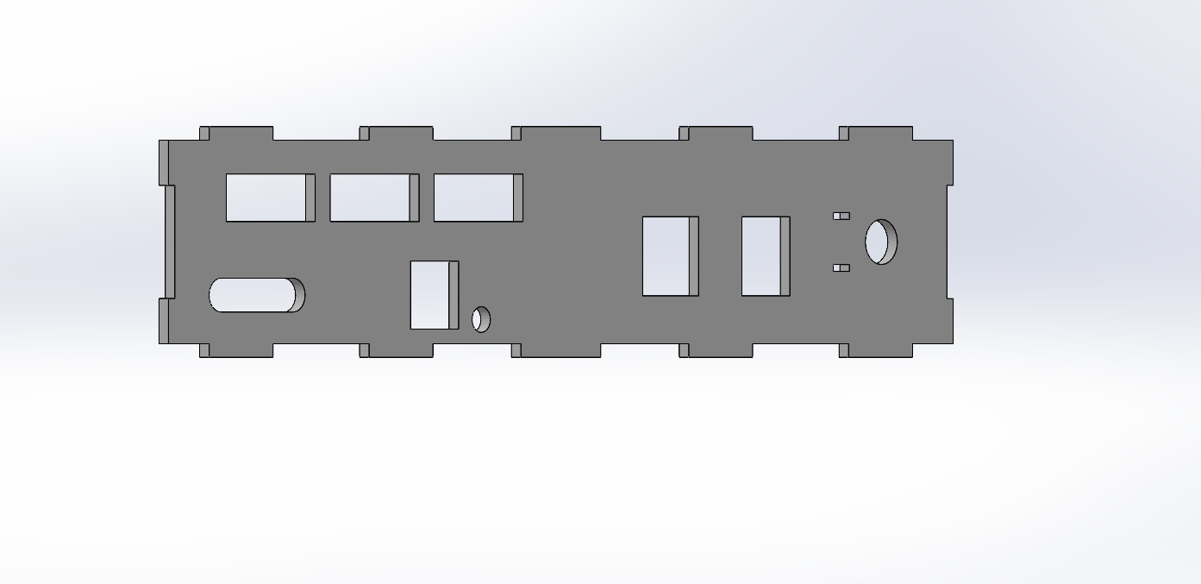
Figure 5: Side view
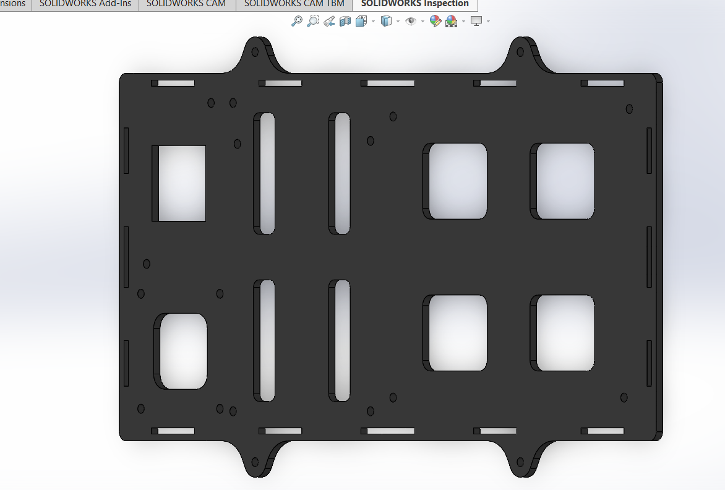
Figure 6: Mounting view
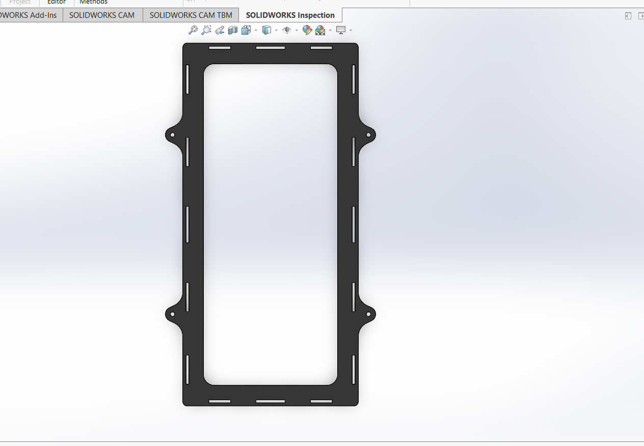
Figure 7: Close-up detail

Difficulties:
Modeling the parts was the easy part. Getting them actually machined turned out to be a bigger headache than expected:
- These parts are small, so most shops just weren't interested — small jobs aren't worth their time.
- Nobody wanted to run a VMC machine for such a low quantity. Setting up the machine takes almost the same time whether you're making 2 parts or 200, so shops didn't see the point for a small order.
- Because of that setup cost, the machining would've cost more than the parts are actually worth.
- The small holes and thin sections meant slower, more careful machining, which made shops even less willing to take it on.
- A lot of the shops we contacted either quoted way too high or just turned the job down.
- There's also a good bit of material wasted when cutting small parts from standard stock, which shops don't like eating the cost for on a small run.
In the end, we're looking at smaller job-shops, trying to bundle the parts into one setup, and considering 3D printing for the non-critical pieces like the holder and the bucket.

